Nama : Yusuf Raja Tamba

Kode Peserta : JVSB001ONL003

Nama Tugas : Best Practice DDL & DML - Sesi 12

Requirements 1

1. Membuat Database PT Melodi Indah

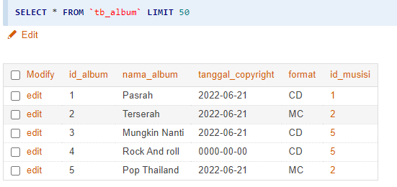

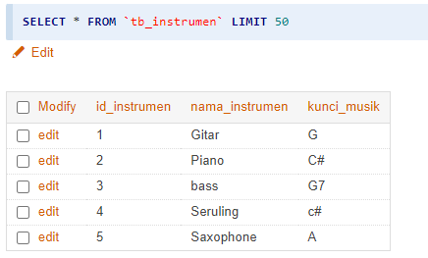

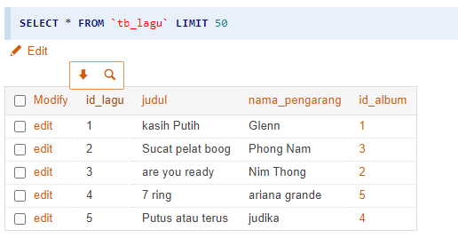

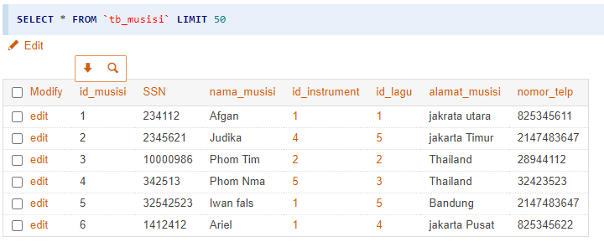

1. Menampilkan nama musisi, nama instrument dan kunci music

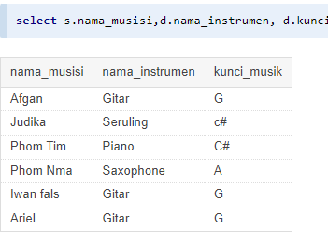

[**select**](https://mariadb.com/kb/en/library/select/) s.nama\_musisi,d.nama\_instrumen, d.kunci\_musik from [tb\_musisi](http://localhost/adminer/?server=localhost&username=root&db=db_ptmelodi&table=tb_musisi) s [**join**](https://mariadb.com/kb/en/library/join/) [tb\_instrumen](http://localhost/adminer/?server=localhost&username=root&db=db_ptmelodi&table=tb_instrumen) d on s.id\_instrument=d.id\_instrumen

1. Menampilkan nama musisi yang menggunakan instrument “Gitar”

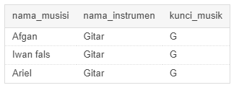

[**select**](https://mariadb.com/kb/en/library/select/) s.nama\_musisi,d.nama\_instrumen, d.kunci\_musik from [tb\_musisi](http://localhost/adminer/?server=localhost&username=root&db=db_ptmelodi&table=tb_musisi) s [**join**](https://mariadb.com/kb/en/library/join/) [tb\_instrumen](http://localhost/adminer/?server=localhost&username=root&db=db_ptmelodi&table=tb_instrumen) d on s.id\_instrument=d.id\_instrumen where d.nama\_instrumen="gitar";

1. Melakukan combine tb\_lagu dengan tb\_album

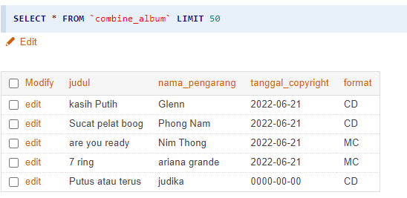

[**create view**](https://mariadb.com/kb/en/library/create-view/) [combine\_test](http://localhost/adminer/?server=localhost&username=root&db=db_ptmelodi&table=combine_test) as [**select**](https://mariadb.com/kb/en/library/select/) a.judul, a.nama\_pengarang, s.tanggal\_copyright, s.format from [tb\_lagu](http://localhost/adminer/?server=localhost&username=root&db=db_ptmelodi&table=tb_lagu) a [**join**](https://mariadb.com/kb/en/library/join/) [tb\_album](http://localhost/adminer/?server=localhost&username=root&db=db_ptmelodi&table=tb_album) s on a.id\_album=s.id\_album;

1. Menampilkan combine tb\_album dengan join musisi

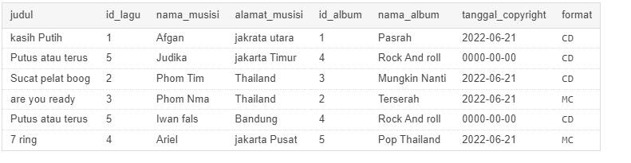

[**select**](https://mariadb.com/kb/en/library/select/) a.judul, a.id\_lagu, c.nama\_musisi, c.alamat\_musisi,a.id\_album,a.nama\_album,a.tanggal\_copyright,a.format from [combine\_album](http://localhost/adminer/?server=localhost&username=root&db=db_ptmelodi&table=combine_album) a [**join**](https://mariadb.com/kb/en/library/join/) [tb\_musisi](http://localhost/adminer/?server=localhost&username=root&db=db_ptmelodi&table=tb_musisi) c on c.id\_lagu=a.id\_lagu;

Requirements 2

struktur database company seperti berikut

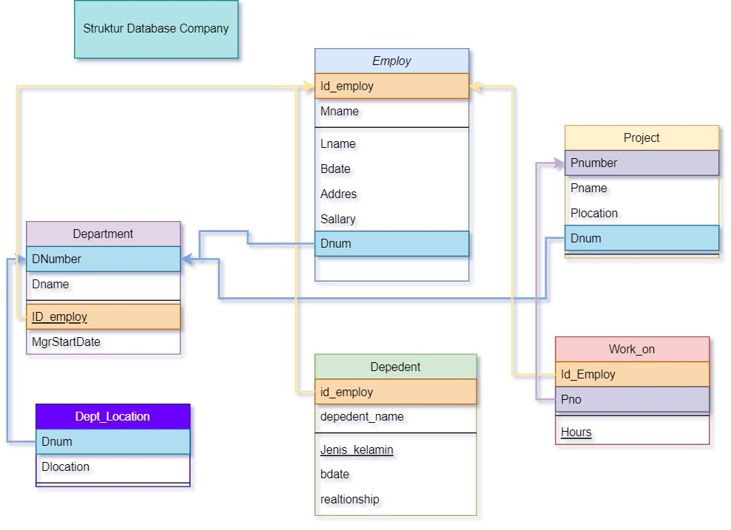

Requirements 3

Dari Database Company lakukan query sebagai berikut

1. Tampilkan dependent\_name dan relationship dengan employee yang namanya diawali huruf R ? “Cuma karena tidak ada huruf R, kita ganti jadi huruf M, ☺

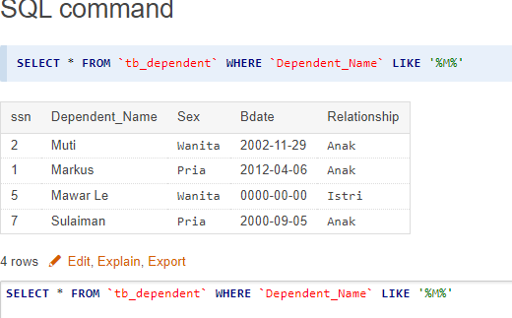

[**SELECT**](https://mariadb.com/kb/en/library/select/) \* FROM `[tb\_dependent](http://localhost/adminer/?server=localhost&username=root&db=employ&table=tb_dependent)` WHERE `Dependent\_Name` [**LIKE**](https://mariadb.com/kb/en/library/string-comparison-functions/#operator_like) '%M%'

1. Banyaknya employee yang mengerjakan project PNum = 1 ?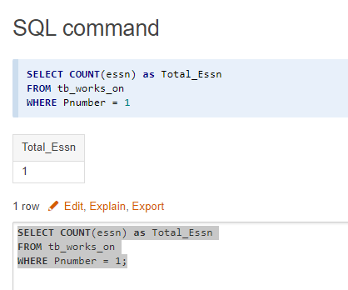

[**SELECT**](https://mariadb.com/kb/en/library/select/) [**COUNT**](https://mariadb.com/kb/en/library/group-by-functions/#function_count)(essn) as Total\_Essn  
FROM [tb\_works\_on](http://localhost/adminer/?server=localhost&username=root&db=employ&table=tb_works_on)  
WHERE Pnumber = 1;

1. Banyaknya employee yang memiliki salary lebih dari 3500000 ?

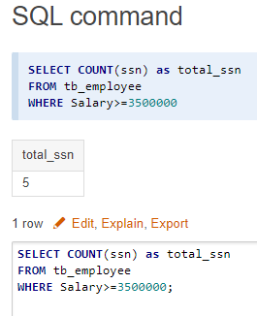

[**SELECT**](https://mariadb.com/kb/en/library/select/) [**COUNT**](https://mariadb.com/kb/en/library/group-by-functions/#function_count)(ssn) as total\_ssn  
FROM [tb\_employee](http://localhost/adminer/?server=localhost&username=root&db=employ&table=tb_employee)  
WHERE Salary>=3500000;

1. Banyaknya project yang dikerjakan DNum =2 ? karena DNum lupa dimasukin di fiel izin ganti ke Dnum=10 ya mas.. ☺

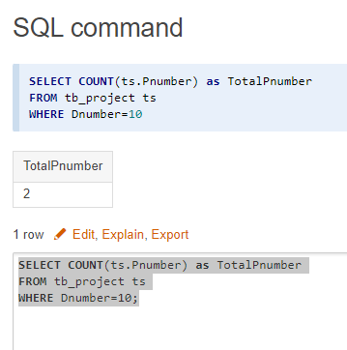

[**SELECT**](https://mariadb.com/kb/en/library/select/) [**COUNT**](https://mariadb.com/kb/en/library/group-by-functions/#function_count)(ts.Pnumber) as TotalPnumber  
FROM [tb\_project](http://localhost/adminer/?server=localhost&username=root&db=employ&table=tb_project) ts  
WHERE Dnumber=10;

1. Hitung total dan rata-rata salary dari setiap departemen ?

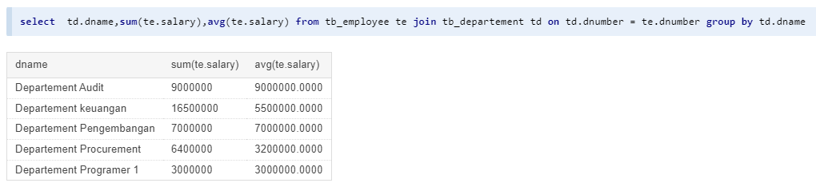

[**select**](https://mariadb.com/kb/en/library/select/) te.fname, [**sum**](https://mariadb.com/kb/en/library/group-by-functions/#function_sum)(te.salary),**[avg](https://mariadb.com/kb/en/library/group-by-functions/" \l "function_avg" \t "_blank)**(te.salary),te.dnumber, td.dname from [tb\_employee](http://localhost/adminer/?server=localhost&username=root&db=employ&table=tb_employee) te [**join**](https://mariadb.com/kb/en/library/join/) [tb\_departement](http://localhost/adminer/?server=localhost&username=root&db=employ&table=tb_departement) td on td.dnumber = te.dnumber group by dnumber

1. Banyaknya employee dari setiap department dan urutkan berdasarkan employee terbanyak ?

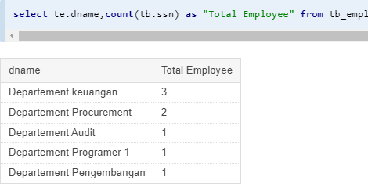

[**select**](https://mariadb.com/kb/en/library/select/) te.dname,[**count**](https://mariadb.com/kb/en/library/group-by-functions/#function_count)(tb.ssn) as "Total Employee" from [tb\_employee](http://localhost/adminer/?server=localhost&username=root&db=employ&table=tb_employee) tb [**join**](https://mariadb.com/kb/en/library/join/) [tb\_departement](http://localhost/adminer/?server=localhost&username=root&db=employ&table=tb_departement) te on tb.dnumber=te.dnumber group by te.dnumber order by [**count**](https://mariadb.com/kb/en/library/group-by-functions/#function_count)(tb.ssn) desc

1. Total hours perweek dari semua employee untuk setiap project ?

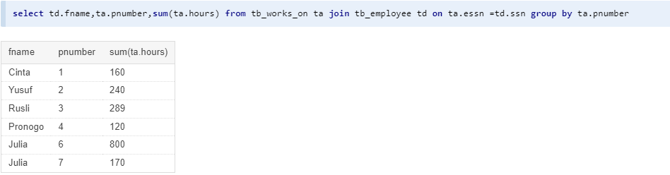

[**select**](https://mariadb.com/kb/en/library/select/) td.fname,ta.pnumber,[**sum**](https://mariadb.com/kb/en/library/group-by-functions/#function_sum)(ta.hours) from [tb\_works\_on](http://localhost/adminer/?server=localhost&username=root&db=employ&table=tb_works_on) ta [**join**](https://mariadb.com/kb/en/library/join/) [tb\_employee](http://localhost/adminer/?server=localhost&username=root&db=employ&table=tb_employee) td on ta.essn =td.ssn group by ta.pnumber

1. Employee yang memiliki total hours perweek lebih besar dari 140 hours dan urutkan berdasarkan jumlah jam kerja terbanyak?

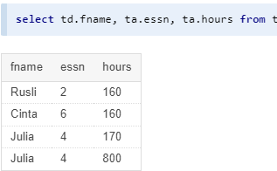

[**select**](https://mariadb.com/kb/en/library/select/) td.fname, ta.essn, ta.hours from [tb\_employee](http://localhost/adminer/?server=localhost&username=root&db=employ&table=tb_employee) td [**join**](https://mariadb.com/kb/en/library/join/) [tb\_works\_on](http://localhost/adminer/?server=localhost&username=root&db=employ&table=tb_works_on) ta on ta.essn = td.ssn where ta.hours>=140 order by ta.hours

1. Kelompokkan bonus employee berdasarkan jumlah jam kerjanya ? (Jika >= 200 hours, maka bonus = 50%; Jika >= 150 hours, maka bonus = 25%, Selainnya bonus = 10%)

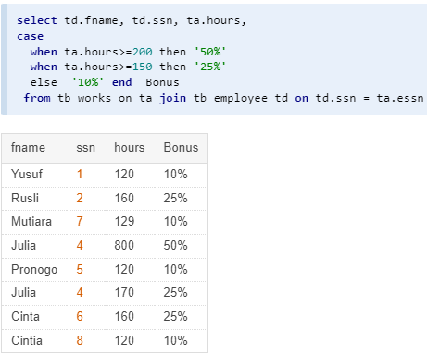

[**select**](https://mariadb.com/kb/en/library/select/) td.fname, td.ssn, ta.hours,  
[**case**](https://mariadb.com/kb/en/library/control-flow-functions/#operator_case)   
  when ta.hours>=200 then '50%'  
  when ta.hours>=150 then '25%'  
  else  '10%' [**end**](https://mariadb.com/kb/en/library/begin-end/)  Bonus   
 from [tb\_works\_on](http://localhost/adminer/?server=localhost&username=root&db=employ&table=tb_works_on) ta [**join**](https://mariadb.com/kb/en/library/join/) [tb\_employee](http://localhost/adminer/?server=localhost&username=root&db=employ&table=tb_employee) td on td.ssn = ta.essn

1. Banyaknya project yang dikerjakan tiap employee dan urutkan dari yang terbanyak ?

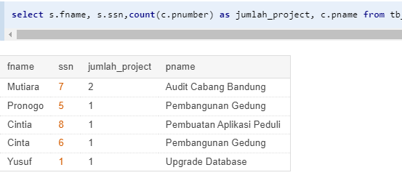

[**select**](https://mariadb.com/kb/en/library/select/) s.fname, s.ssn,[**count**](https://mariadb.com/kb/en/library/group-by-functions/#function_count)(c.pnumber) as jumlah\_project, c.pname from [tb\_employee](http://localhost/adminer/?server=localhost&username=root&db=employ&table=tb_employee) s [**join**](https://mariadb.com/kb/en/library/join/) [tb\_project](http://localhost/adminer/?server=localhost&username=root&db=employ&table=tb_project) c on s.dnumber=c.dnumber group by ssn  order by [**count**](https://mariadb.com/kb/en/library/group-by-functions/#function_count)(c.pnumber) desc;

1. Employee yang bekerja pada 4 project ?

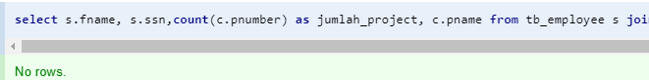

[**select**](https://mariadb.com/kb/en/library/select/) s.fname, s.ssn,[**count**](https://mariadb.com/kb/en/library/group-by-functions/#function_count)(c.pnumber) as jumlah\_project, c.pname from [tb\_employee](http://localhost/adminer/?server=localhost&username=root&db=employ&table=tb_employee) s [**join**](https://mariadb.com/kb/en/library/join/) [tb\_project](http://localhost/adminer/?server=localhost&username=root&db=employ&table=tb_project) c on s.dnumber=c.dnumber group by ssn having [**count**](https://mariadb.com/kb/en/library/group-by-functions/#function_count)(c.pnumber)>=4 order by [**count**](https://mariadb.com/kb/en/library/group-by-functions/#function_count)(c.pnumber) desc;

1. Employee yang memiliki rata-rata hours perweek = 70 jam dan bekerja pada 2 project ?

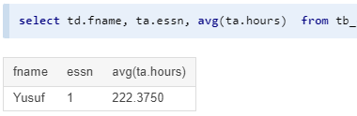

[**select**](https://mariadb.com/kb/en/library/select/) td.fname, ta.essn, [**avg**](https://mariadb.com/kb/en/library/group-by-functions/#function_avg)(ta.hours)  from [tb\_employee](http://localhost/adminer/?server=localhost&username=root&db=employ&table=tb_employee) td [**join**](https://mariadb.com/kb/en/library/join/) [tb\_works\_on](http://localhost/adminer/?server=localhost&username=root&db=employ&table=tb_works_on) ta on ta.essn = td.ssn where ta.hours>=70 order by ta.hours;

1. Banyaknya Dependent berdasarkan relationship dengan employee ?

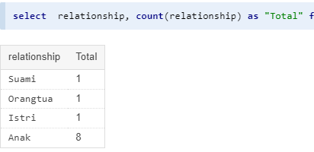

[**select**](https://mariadb.com/kb/en/library/select/)  relationship, [**count**](https://mariadb.com/kb/en/library/group-by-functions/#function_count)(relationship) as "Total" from  [tb\_dependent](http://localhost/adminer/?server=localhost&username=root&db=employ&table=tb_dependent)  group by relationship order by [**count**](https://mariadb.com/kb/en/library/group-by-functions/#function_count)(relationship) asc;

1. Berapa lama Manager tiap Department sudah menjabat ?

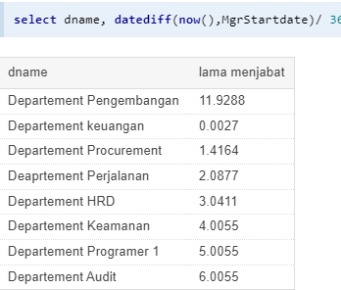

[**select**](https://mariadb.com/kb/en/library/select/) dname, [**datediff**](https://mariadb.com/kb/en/library/date-and-time-functions/#function_datediff)([**now**](https://mariadb.com/kb/en/library/date-and-time-functions/#function_now)(),MgrStartdate)/ 365 as "lama menjabat" from [tb\_departement](http://localhost/adminer/?server=localhost&username=root&db=employ&table=tb_departement)

1. Lokasi project yang menjadi tempat lebih dari satu department?

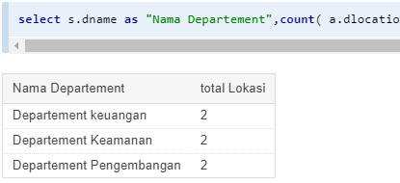

[**select**](https://mariadb.com/kb/en/library/select/) s.dname as "Nama Departement",[**count**](https://mariadb.com/kb/en/library/group-by-functions/#function_count)( a.dlocation) as "total Lokasi" from [tb\_departement](http://localhost/adminer/?server=localhost&username=root&db=employ&table=tb_departement) s [**join**](https://mariadb.com/kb/en/library/join/) [tb\_deot\_location](http://localhost/adminer/?server=localhost&username=root&db=employ&table=tb_deot_location) a on s.dnumber=a.dnumber group by dlocation  having [**count**](https://mariadb.com/kb/en/library/group-by-functions/#function_count)(a.dlocation)=2;

**Sql full check:**

SELECT dependent\_name, relationship FROM tb\_dependent WHERE dependent\_name LIKE '%M%';

SELECT COUNT(essn) as Total\_Essn FROM tb\_works\_on WHERE Pnumber = 1;

SELECT COUNT(ssn) as total\_ssn FROM tb\_employee WHERE Salary>=3500000;

SELECT COUNT(ts.Pnumber) as TotalPnumber FROM tb\_project ts WHERE Dnumber=10;

select td.dname,sum(te.salary),avg(te.salary) from tb\_employee te join tb\_departement td on td.dnumber = te.dnumber group by td.dname;

select te.dname,count(tb.ssn) as "Total Employee" from tb\_employee tb join tb\_departement te on tb.dnumber=te.dnumber group by te.dnumber order by count(tb.ssn) desc;

select td.fname,ta.pnumber,sum(ta.hours) from tb\_works\_on ta join tb\_employee td on ta.essn =td.ssn group by ta.pnumber;

select td.fname, ta.essn, ta.hours from tb\_employee td join tb\_works\_on ta on ta.essn = td.ssn where ta.hours>=140 order by ta.hours;

select td.fname, ta.essn, ta.hours from tb\_employee td join tb\_works\_on ta on ta.essn = td.ssn where ta.hours>=140 order by ta.hours;

select td.fname, td.ssn, ta.hours,

case

when ta.hours>=200 then '50%'

when ta.hours>=150 then '25%'

else '10%' end Bonus

from tb\_works\_on ta join tb\_employee td on td.ssn = ta.essn;

select s.fname, s.ssn,count(c.pnumber) as jumlah\_project, c.pname from tb\_employee s join tb\_project c on s.dnumber=c.dnumber group by ssn order by count(c.pnumber) desc;

select s.fname, s.ssn,count(c.pnumber) as jumlah\_project, c.pname from tb\_employee s join tb\_project c on s.dnumber=c.dnumber group by ssn having count(c.pnumber)>=4 order by count(c.pnumber) desc;

select td.fname, ta.essn, avg(ta.hours) from tb\_employee td join tb\_works\_on ta on ta.essn = td.ssn where ta.hours>=70 order by ta.hours;

select relationship, count(relationship) as "Total" from tb\_dependent group by relationship order by count(relationship) asc;

select dname, datediff(now(),MgrStartdate)/ 365 as "lama menjabat" from tb\_departement;

select s.dname as "Nama Departement",count( a.dlocation) as "total Lokasi" from tb\_departement s join tb\_deot\_location a on s.dnumber=a.dnumber group by dlocation having count(a.dlocation)=2;